Learning Disability Week – Marie Gibb Award
Easy Read Nomination Form

Who Was Marie Gibb?
Marie was a nurse.
She worked with people with a learning disability.
She helped people live happier and healthier lives.

🏆 What Is the Award For?
The award celebrates people who help others.
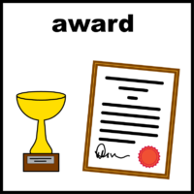
You can nominate:
👩 A person
🧑‍🤝‍🧑 A group
🧑‍⚕️ A worker or professional
🧑‍🦽 A person with a learning disability

Example from last year
A group won the award.
They helped people with a learning disability for over 15 years.

They included:
🧑‍🦽 People with lived experience
👪 Family carers
🧑‍⚕️ Support staff
🏛 People from different services

They spoke up and campaigned for better support.

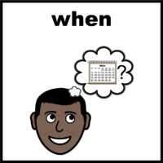
🗓️ Important Dates
Last day to send in your nomination: Friday 24th April
You may be invited to the ceremony at Wakefield Cathedral on Monday 15th June.
The award will be given out at this event

Where to send this form
You can give us this form in the way that is easiest for you — by post, in person, or by email.
- to adultsocialcare@wakefield.gov.uk
Or
- post - Put your form in an envelope and post it to Marie Gibb Award, Room G19, Waterton Connecting Care Hub, Waterton Road, Wakefield, West Yorkshire, WF2 8HTr
Or
- Drop it in person to any of these places
City Limits, Thornhill Street, Wakefield, WF1 1NL
Clarence Court, 158, Lawefield Lane, Wakefield, WF2 8SX
Pontefract Day Opps, 33, Newgate, Pontefract WF8 INB
Kinsley Day Opps, 58, Wakefield Road, Kinsley WF9 5EB

Tell us who should get the award?


1️⃣ Question 1 – Who should win?
You can choose one person or a group.

Nominee (the person or group you want to win)

Full name: ____________________________
Email or other contact details: ________________________________
Your details (the person filling in this form)

Your email or contact details:
____________________________________________


2️⃣ Question 2 – Why should they win?
Tell us:
💬 What they have done
🤝 How they help people
🌟 Why they are special
💡 What difference they make
You can write your answers on this form.
Or you can write your answers on your own paper.
✋ Please do not write more than 250 words.
________________________________________________________________________________________________________________________________________________________________________________________________________________________________________________________________________________________________________________________________________________________________________________________________________________________________________________________________________________________________________________________________________________________________________________________________________________________

