

Health and Social Care

Complaints Self Help Pack

What you will find in this pack
1. Introduction to complaints 4
2. Step-by-step complaints process 5
3. Writing a complaint letter 6
4. Knowing your rights 8
5. Support and advocacy services 9
6. Other ways to give feedback or get support 10
7. Next steps if unresolved 11
8. Regulators 12
9. Quick tips for managing the process 14
10. Useful resources 15
Complaint Log 16
A flow chart of the process of making a complaint 18

If you need information in another format, please get in touch.

Registered Company No. 09907848 and Charity No. 1166797 Registered in England and Wales

1. Introduction to complaints

Purpose of this pack
This pack is designed to help you navigate the complaints process for health and social care services. It provides tools, templates, and tips to ensure your concerns are heard and addressed effectively.

Who can complain?
- Patients, service users, or clients.
- Family members, carers, or representatives.
- Advocates acting on someone’s behalf.

What can you complain about?
- Delayed or inadequate care.
- Communication issues.
- Staff behaviour or attitudes.
- Incorrect diagnoses or treatment errors.
- Accessibility problems or lack of support.

When to complain
- Complaints should normally be made within 12 months of an incident or of it coming to your attention.
- This time limit can be extended provided you have good reasons for not making the complaint sooner and it’s possible to complete a fair investigation.

2. Step-by-step complaints process

Step 1: identify the issue
- Reflect on what went wrong and the outcome you’re seeking.
- Gather evidence, for example appointment details, letters.

Step 2: speak informally
- Contact the service provider directly, for example GP practice manager, care home manager, home care provider, hospital ward staff.
- Request a meeting to discuss your concerns and seek a resolution.

Or make a formal complaint
- Write a complaint letter or email using the template provided.
- Send your complaint to the service provider’s complaints team.

Step 3: follow up
- Keep records of responses and timelines.
- If you don’t receive your response within the expected time limit, contact the organisation again.

Step 4: Once you receive the response
- Review the response against your complaint and make a note of any specific points which you are not satisfied with, and any questions which have not been addressed or not answered to your satisfaction.
- Decide whether all your outcomes have been achieved.
- The organisation should explain what your next step is if you need clarification, more information or if you have any remaining concerns or questions arising out of the information provided in the response.

Step 5: Final response and remaining concerns
- If you receive a final response to your complaint and any remaining concerns, you have the option to escalate your complaint to either the Parliamentary Health Service Ombudsman, also known as the PHSO, for health, or the Local Government and Social Care Ombudsman, also known as the LGSCO, for social care. See 7: Next steps if unresolved for their contact details and links to more information about their process.

3. Writing a complaint letter

Template complaint letter
[Your Name]
[Your Address]
[City, Postcode]
[Date]
[Recipient's Name/Complaints Team]
[Organisation Name]
[Address]
[City, Postcode]

Subject: Formal Complaint Regarding [Service/Issue]
Dear [Recipient's Name],
I am writing to formally raise a complaint regarding the care/service I received from [organisation/service name] on [date(s)].

Details of the complaint:
- What happened: [Brief description of the event or issue].
- When and where it occurred: [Provide specific dates and locations].
- People involved: [Mention staff or departments, if relevant].
- List any questions you want answers to.

Impact of the issue:
[Explain how the problem has affected you or your loved one.]

Steps already taken:
[Describe any previous actions you’ve taken to resolve the issue.]

Desired outcome:
[State what resolution you are seeking, such as explanations, answers to questions, an apology, policy change, or reimbursement.]
Thank you for taking the time to address my concerns. I look forward to your response within the time outlined in your complaints policy.
[OR, if you prefer to make a more formal request]
I look forward to receiving your acknowledgement of this letter. I would like you to carry out a full investigation into my concerns and provide me with a response in accordance with The Local Authority Social Services and National Health Service Complaints (England) Regulations 2009.

Yours sincerely,
[Your Name]

4. Knowing your rights

Key rights to know
NHS Constitution for England: Ensures your right to make complaints and receive a response.
https://www.gov.uk/government/publications/the-nhs-constitution-for-england/the-nhs-constitution-for-england

Care Act 2014: Protects those receiving care and outlines accountability.
https://www.legislation.gov.uk/ukpga/2014/23/contents

Typical times to expect
- Acknowledgment: Within three working days.
- Full response: Varies but typically can be up to 40–60 working days.

5. Support and advocacy services

Key contacts
Healthwatch Wakefield for independent advice and support.
Telephone 01924 787379
Text 07885 913396
Email enquiries@healthwatchwakefield.co.uk
Website www.healthwatchwakefield.co.uk
Registered Office at The Plex, 15 Margaret Street, Wakefield WF1 2DQ

Independent NHS Complaints Advocacy Service for support with any stage of the NHS Complaints Procedure.
Contact through Healthwatch Wakefield, details above.

Patient Advice and Liaison Service (PALS): NHS specific guidance.
Depending on which NHS service you are complaining about, there are different PALS services.

6. Other ways to give feedback or get support

Feedback through:
Care Opinion
The General Dental Council
The General Medical Council
The Healthwatch Wakefield’s Feedback Centre you can rate and review services
The NHS
NHS Friends and Family Test

Get support:
Find your Councillor online or Telephone 0345 8 506 506
Find your Member of Parliament
Citizens Advice for everyone on health and care issues.
Action Against Medical Accidents AVMA for people affected by medical accidents.
The Patients Association for all patients and their families.
Age UK for older people.
Independent Age for older people.
Residents and Relatives Association for older people in care.
Mencap for people with a learning disability.
Mind for people affected by mental illness.
Rethink for people affected by mental illness.

7. Next steps if unresolved

Ombudsman

Parliamentary and Health Service Ombudsman (PHSO)
For unresolved NHS complaints.
Telephone 0345 015 4033
There is also an online form and complaint checker.
Website https://www.ombudsman.org.uk/

Local Government and Social Care Ombudsman (LGSCO)
For unresolved social care issues.
Telephone 0300 061 0614
There are also online and postal options.
Website https://www.lgo.org.uk/

8. Regulators

Care Quality Commission (CQC)
The independent regulator of health and social care in England. Report systemic issues in care standards.
Telephone 03000 616161
Email enquiries@cqc.org.uk
There is also an online option.
Website https://www.cqc.org.uk/

Health regulators

The General Chiropractic Council (GCC)
Regulates: Chiropractors
Telephone 020 7713 5155
Website www.gcc-uk.org

The General Dental Council (GDC)
Regulates: Dentists, dental therapists, dental nurses, dental technicians, clinical dental technicians, and orthodontic therapists
Telephone 020 7887 3800
Website www.gdc-uk.org

The General Medical Council (GMC)
Regulates: Doctors
Telephone 0845 357 8001
Website www.gmc-uk.org

The General Optical Council (GOC)
Regulates: Dispensing opticians and optometrists
Telephone 020 7580 3898
Website www.optical.org

The General Osteopathic Council (GOsC)
Regulates: Osteopaths
Telephone 020 7357 6655
Website www.osteopathy.org.uk

The Nursing and Midwifery Council (NMC)
Regulates: Nurses, midwives, nursing associates in England and specialist community public health nurses.
Telephone 020 7333 6622
Website www.nmc-uk.org

General Pharmaceutical Council (GPhC)
Regulates: pharmacists, pharmacy technicians, and pharmacy premises.
Telephone 020 3713 8000
Website www.pharmacyregulation.org

The Professional Standards Authority (PSA)
The independent body overseeing 10 Health and Social care regulators in the UK.
Telephone 0207 839 8030
Website www.professionalstandards.org.uk

Social Care regulators

Social Work England (SWE)
The independent regulator for Social Workers in England.
Telephone 0808 196 2272
Website www.socialworkengland.org.uk

9. Quick tips for managing the process

Stay organised
- Keep copies of all letters, emails, and notes from telephone conversations.
- Send photocopies or scans of original documents.
- Maintain a timeline of events.

Be clear and straightforward
- Use short sentences.
- Be clear and concise.
- If the complaint is long and complex attach a log sheet or diary of events with details.
- Don’t be afraid to say what upset you but avoid aggressive or accusing language.
- Focus on facts and try not to repeat yourself.

Be constructive
- Your complaint is an opportunity to improve things.

Be persistent
- Follow up if you don’t receive timely responses.
- Be aware of when to escalate your complaint.
For example, with a health complaint, if you haven’t received any contact from an organisation 6 months from when you complained you can take it to the Parliamentary Health Service Ombudsman.
For social care, the Ombudsman says If you are not happy with the response you receive from the council or the care provider, or if you do not get an answer within a reasonable time, you can complain to them. They think up to 12 weeks is a reasonable time for a council or care provider to look at your complaint and reply to you. Occasionally they will look at a complaint straight away, for example if they decide someone is especially vulnerable.

10. Useful resources
One the next pages you will find:
- A flow chart that shows the process of making a complaint about social care or health care.
- A complaint log.

We have also included:
- A Healthwatch Wakefield leaflet.
- A Healthwatch Wakefield NHS Complaints Advocacy leaflet.
- A page or pages that relate to the service you want to complain about.

You can also find more resources on our website.

Remember

If at any point you need more advice, information, or support you can contact us at Healthwatch Wakefield.

Complaint Log
- Date
- Who did you contact? Name and job title.
- How did you make contact? For example, was it a telephone call, email, letter, or meeting?
- What did they agree to?
- What did you agree to do?
Date | Who | How | What did they agree to do | What did you agree to do

Date | Who | How | What did they agree to do | What did you agree to do

A flow chart of the process of making a complaint
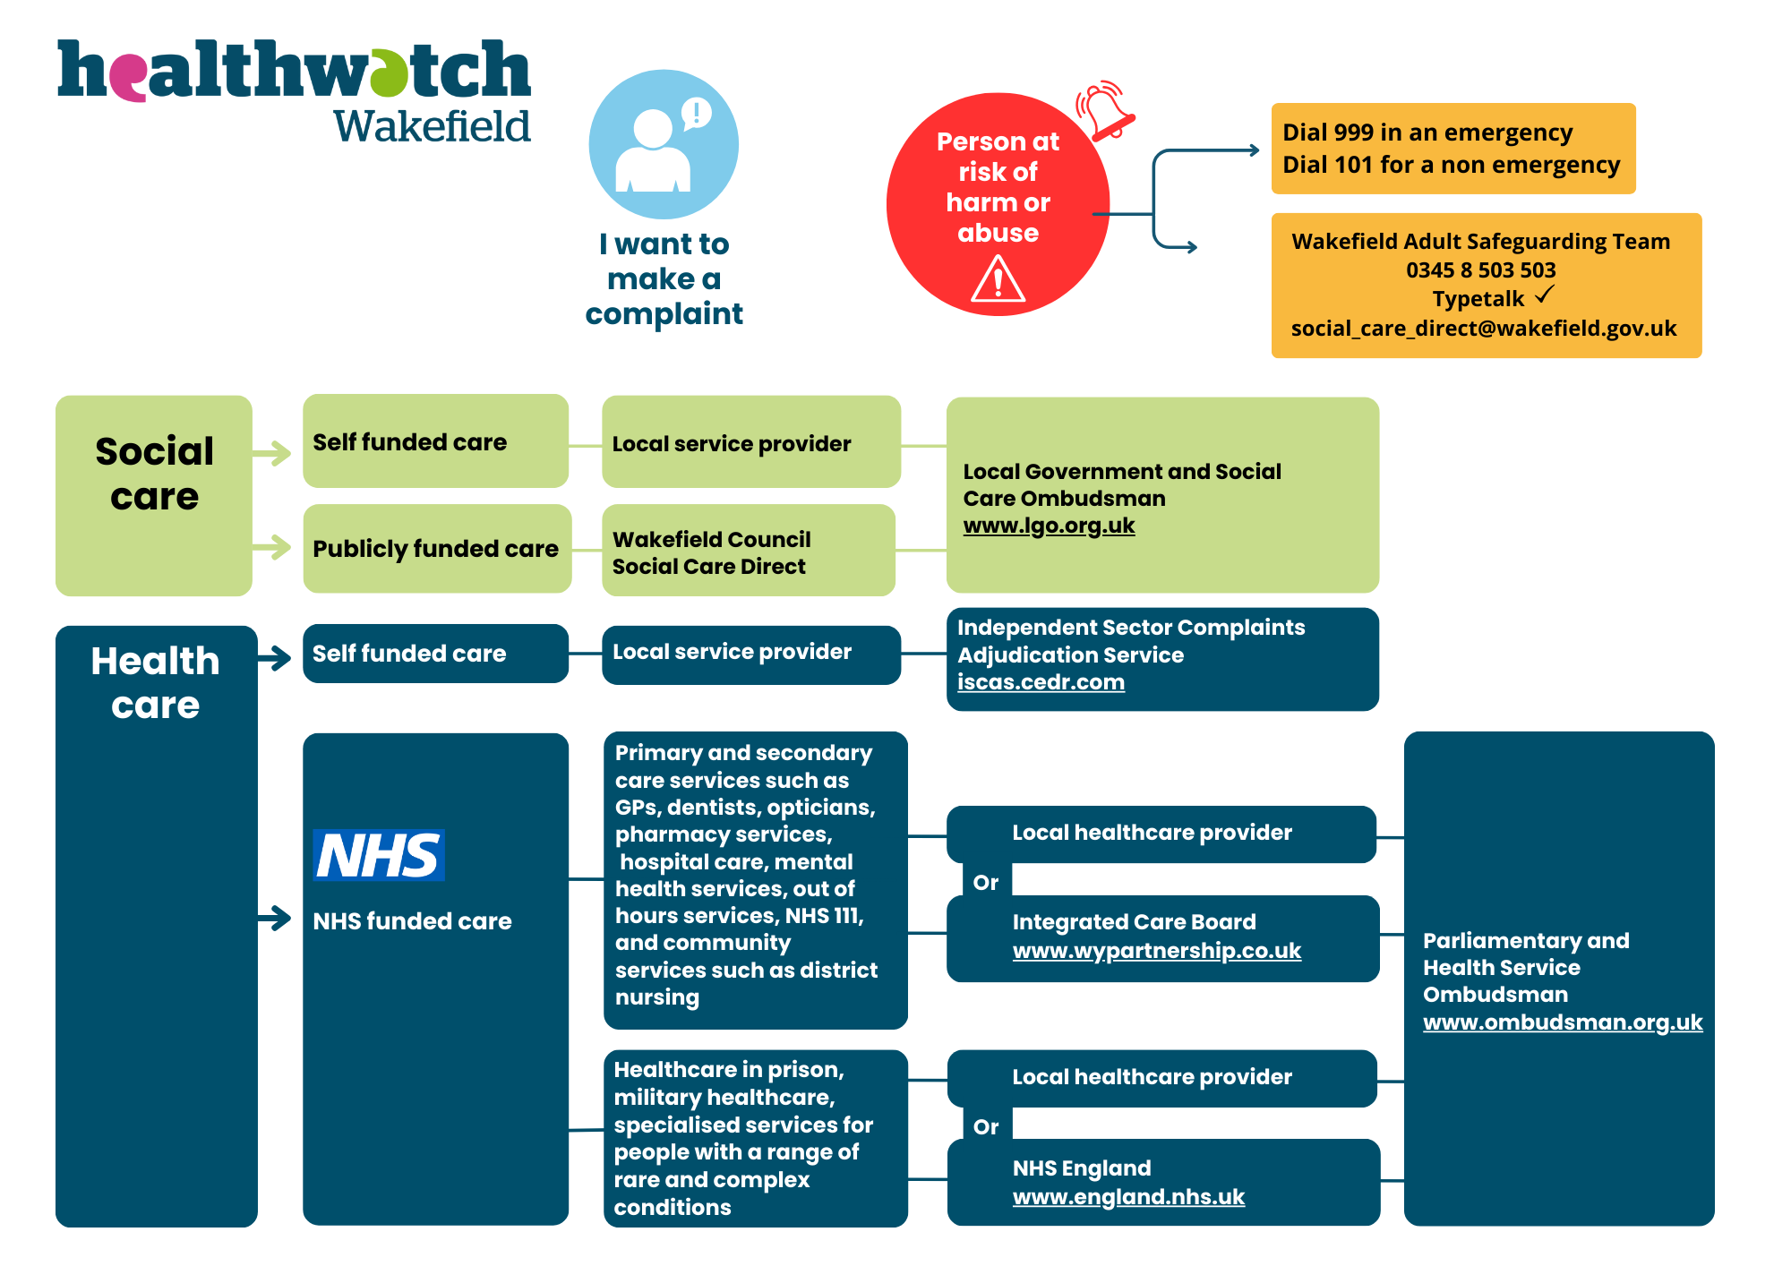

Telephone 01924 787379
Text 07885 913396
Email enquiries@healthwatchwakefield.co.uk
Website www.healthwatchwakefield.co.uk
Registered Office at The Plex, 15 Margaret Street, Wakefield WF1 2DQ

We are social people. Find and follow us.

