

Support, advice, and information after a stroke
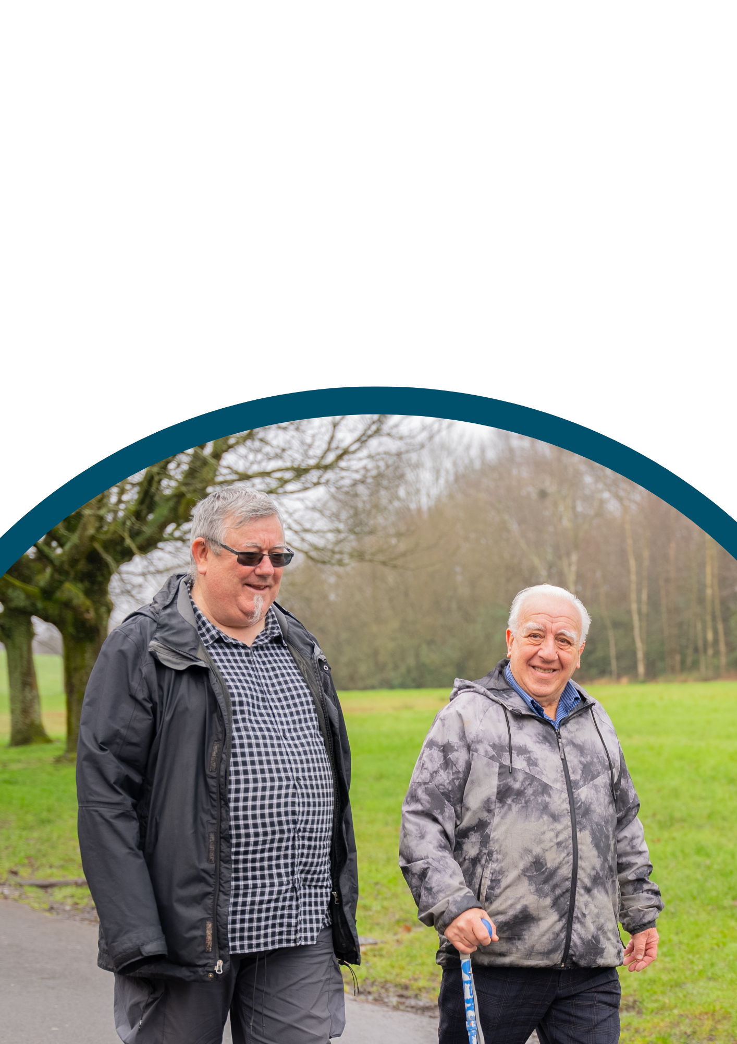

How to find support, advice and information after a stroke
Figures from the Stroke Association show there are more than 100,000 strokes in the UK each year. That's around one stroke every five minutes. But no two strokes are the same, which means there is no set pattern for recovering from one. It also depends on the type of stroke you have and the stroke services that are available in your area.
Medical information can be found on the NHS website www.nhs/conditions/stroke.
A stroke is when blood stops flowing to a part of your brain. This can be because of a blockage or a bleed. A stroke can affect things like speech and movement, and it can take a long time to recover.
A stroke needs urgent medical help in hospital because it can be life-threatening.

National organisations
You can get support, advice, and information from national charities and organisations. We have listed some of them here.

The Stroke Association
The Stroke Association is a national charity that exists to provide lifelong support for all stroke survivors and their families.
Their key areas of work include Stroke Support Coordinators; their Stroke Support Helpline - the only national helpline for all stroke survivors and their loved ones where one call opens up a world of wider support; information; research; and campaigning.
They offer weekly calls, online activities, and support groups.

Contact details
Stroke Support Helpline on 0303 3033 100 or email helpline@stroke.org.uk.
Website https://www.stroke.org.uk/

Weekly Volunteer Calls
Weekly conversations with one of the trained volunteers. Sign up for weekly volunteer calls by using this link www.stroke.org.uk/webform/here-you-sign-form, call the helpline or email.

Online Activities
A great way to meet new people, feel more supported and increase your confidence. Sign up for online activities by using this link www.stroke.org.uk/webform/online-stroke-activities-hub, call the helpline or email.

Online stroke support groups
Online stroke support groups are a safe and supportive space to try things again, to learn more about stroke and self-care and to build your confidence after your stroke. Sign up for online groups by using this link www.stroke.org.uk/stroke/support/online, call the helpline or email.
The Stroke Association also run local services which can be found further along in this document.

Different Strokes
Different Strokes is run by younger stroke survivors for younger stroke survivors. They have personal experience of the realities of life after stroke. Of the 10,000 strokes that happen in the UK each year; 1 in 4 of these occurs in somebody of working age or younger.

Contact details
Telephone 0345 130 7172 or 01908 317618 or email info@differentstrokes.co.uk.
Website https://differentstrokes.co.uk/

The Brain and Spine Foundation
The Brain and Spine Foundation is a registered charity that exist for anyone affected by any neuro condition, providing guidance and support at every step of your journey. They have a helpline but also offer health information, A to Z topics, fact sheets, and booklets along with real time research opportunities, advice, and peer support groups.

Contact details
To speak to a Helpline Nurse telephone 0808 808 1000 on Monday to Friday, between 9.00 am and 4.00 pm or email helpline@brainandspine.org.uk.
Website https://www.brainandspine.org.uk/

Local and regional organisations

Wakefield Stroke Recovery Service
The Stroke Association Stroke Recovery Service provides you and your family with practical support and information after a stroke. One of their Stroke Support Coordinators will work with you to identify what matters most to you so they can best support you throughout your recovery.

Contact details
Contact Kayleigh Ratcliffe on telephone 01924 372525 or email Wakefield.Team@stroke.org.uk.

West Yorkshire Post-Stroke Reviews
Stroke affects everyone differently. The Stroke Association Stroke Support Coordinators will get in touch to book in your Post-Stroke Review. Your review is a chance to reflect on the progress you have made since having a stroke. It’s a chance for you to talk about things which are important to you and anything you may want support with as you continue your recovery journey.

Contact details
Contact Rebecca Holloway on telephone 0113 201 9794 or email westyorkshire.team@stroke.org.uk.

All Things Stroke
Web pages provided by West Yorkshire Association of Acute Trusts. The Association brings together six NHS trusts across West Yorkshire and Harrogate to deliver joined up acute hospital services. Wide ranging information for both stroke survivors and carers, including on physical, emotional, medical, and financial issues amongst other avenues for support.
Website https://www.wyh-allthingsstroke.nhs.uk/stroke-survivors-and-carers

Wakefield Speakability Group
This group has a focus on people with aphasia, giving them a chance to interact with other people. Aphasia, also called dysphasia, is a condition that makes it difficult to communicate.
It can make it hard to speak, read, write, and understand others. The group have a varied programme of activities, including games, outside speakers and visits.
This group is run by The Stroke Association. Meetings are on the first Tuesday of the month, except for January.
They meet at The White Horse Inn, 49 West Lane, Sharlston Common, Wakefield WF4 1EP.

Contact details
Telephone Norman Howe on 07720 285246.

Aphasia Support
Aphasia Support is a charity founded by people with aphasia and their carers. Aphasia, also called dysphasia, is a condition that makes it difficult to communicate. It can make it hard to speak, read, write, and understand others.
Originally known as ‘Speak with IT’, they were established in 2011 by a group from Yorkshire who faced challenges accessing speech and language therapy for themselves or their loved ones.
They provide free tailored speech and language therapy and long-term support, helping people rebuild their confidence, independence, and quality of life.

Contact details
Telephone 0300 102 3500 or email info@aphasiasupport.org, or visit Balne Lane Community Centre, Balne Lane, Wakefield, WF2 0DP.
Website https://www.aphasiasupport.org/

Ossett Stroke Club
Offering social support and friendship, Ossett Stroke Club meeting every couple of weeks in Ossett Community Centre. They enjoy guest speakers and performers, quizzes, raffles, and lunches.

Contact details
Telephone Patricia Sutton on 01924 274406 or find them on Facebook https://www.facebook.com/ossettstrokeclub/.

Outwood Stroke Club
Offering social support and friendship, Outwood Stroke Club meet in Outwood Memorial Hall. They enjoy quizzes, raffles, and lunches. They have trips out and people come to entertain attendees.

Contact details
Telephone Chris Welch on 07775 603809 or find the group on Facebook https://www.facebook.com/groups/586581805279745/.

Second Chance Headway
Second Chance Headway provide a therapy-led centre offering a wide range of day services to adults living with acquired brain injury, including non-traumatic brain injury such as stroke. Their website provides information, guidance and support to people living with brain injury and their family, friends and carers. It includes information about dealing with a brain injury, rehabilitation and continuing care, as well as financial, legal, and other support.

Contact details
Telephone 01924 366735 or email rehab@schc.co.uk, or visit Second Chance Headway Centre, Almshouse Lane, Wakefield WF1 1AD.
Website https://www.secondchancewakefield.com/

Mental health support after a stroke
Having a stroke can affect your mental health. It can help to talk about how you're feeling. You can get talking therapies for free on the NHS. These services can help you find ways to cope. Help is available in person, by video, over the phone or as an online course.
Locally talking therapies are provided by Turning Point Wakefield, who cover the whole District.

Turning Point
Turning Point provide free and confidential support for adults. They offer quick and easy access to a range of psychological therapies. If you are feeling down, worried, depressed, or anxious, they can help, whether that be face-to-face, over the phone or with online support.

Contact details
Telephone 01924 234 860 or email wakefield.talking@turning-point.co.uk.
Website: https://talking.turning-point.co.uk/wakefield

Support for carers

The Stroke Association

Caring for someone close to you after a stroke
When someone close to you leaves hospital after a stroke, you may suddenly find yourself needing to give them help and support. You may have lots of questions and be feeling lots of emotions. This is normal.
It is not just the survivor who is affected after a stroke but anyone supporting them too. You do not need to face supporting someone after their stroke alone. The Stroke Support Helpline is also there for you. Simply give them a call. They can offer information on practical and financial support and looking after your health and wellbeing.

Contact details
Telephone 0303 3033 100 or email helpline@stroke.org.uk.
Website https://www.stroke.org.uk/stroke/support/carers

Different Strokes

Resources for Carers
Different Strokes have a carers section on their website, dedicated to providing vital support and resources for friends and family members of stroke survivors, especially those caring for young stroke survivors.
They have produced an Information Pack designed to offer practical advice and guidance for carers. They also have webinars and videos that address common concerns and provide strategies to enhance your caregiving experience.
There are also monthly virtual meetings for carers, which offer a safe and confidential space to share experiences and find support.
Their Support Line is also available for both stroke survivors and carers.

Contact details
Telephone 0345 130 7172 or email info@differentstrokes.co.uk.
Website https://differentstrokes.co.uk/what-we-do/carers-resources/

Resources for children
They have also created resources specifically to help children in families who have experienced stroke. Their goal is to help start discussions in families and help children understand and express their emotions during what can be a challenging time for everyone involved.
https://differentstrokes.co.uk/what-we-do/family-support/

This information is not an exhaustive list but we hope it helps. You can also find some of these organisations on social media. If you know of other organisations please share them with us.
If you have any questions, need advice, or would like to share an experience of health or care services with us, please get in touch.

Telephone 01924 787379
Text 07885 913396
Email enquiries@healthwatchwakefield.co.uk
Website www.healthwatchwakefield.co.uk
We are social people. Find and follow us.

